Zara Database

**Group 1**

Eduardo Ballesteros Grande A20410861

Raquel Buezo Tordesillas A20410771

Carlota López Pérez-Arroyo A20410752

Table of Contents

Student’s Contribution 3

Entity-Relationship Model 4

Explanation and assumptions 4

ER Diagram 5

Relational Database 6

Assumptions 6

Relational Database Diagram 7

Application 8

# Student’s Contribution

* ER Diagram: Worked together in discussing and elaborating it.
* SQL for Relational Database: Also worked together.
* Application: Worked side by side although we each wrote different parts of the application code. Eduardo mainly focused on the Employee part, while Carlota and Raquel focused on the rest.

# Entity-Relationship Model

## Explanation and assumptions

For our database project, we have chosen the widely known Spanish store called Zara. This store mostly concentrates on selling clothes, shoes and accessories. To create the Entity-Relationship Model, we have taken into account the following considerations:

* In the entity **Product:**
  + Size, color and item will be derived attributes form the *UPC_code*
  + We consider for example that two shirts of the same size and color have the same *UPC_code*
  + *Department* will be used to identify whether it belongs to the Man or Woman section.
  + *Type* will consider the subcategories into which the categories are divided. For example, we will consider dividing clothes into dresses, sweaters, pants, etc.
  + *Description* will be a brief explanation of the characteristics of the product
* In the entity **Store:**
  + *Opens and closes* refers to the schedule of the store
  + *Max_inventory* is the maximum number of products that can be stored
* In the entity **Address:**
  + It is used to have a record of both the address of the customers and the stores
* In the entity **Category:**
  + We consider that each product would be separated into clothes, shoes and accessories
* In the entity **Vendor:**
  + *Delivery_method* refers to the transportation system by which the product would be distributed. This includes train, truck, boat and airplane
  + *Delivery_time* refers to the lead time (time interval since the store poses an order until it receives it)
  + We have considered that we have only one vendor per product
* In the entity **Customer:**
  + We consider that one customer can have several credit cards, so it is a multivalued attribute
* In the relationship **Transactions:**
  + We use it to keep a record of what each customer buys at each store and when it was bought.
* In the relationship **Inventory:**
  + *Price* is placed as an attribute in this relationship because it depends on the store.
  + *Threshold* is the quantity of each product, that when reached informs that a new order should be placed.
  + *Order_quantity* is the quantity that the store orders of each product

*NOTE: The acronym CP found on the ER model, stands for “*Clave Primaria”* which is Spanish for Primary Key.

## ER Diagram

INSERT DIAGRAM HERE, I’M DOING THE EXPLANATION FOR THE LAST ONE

# Relational Database

## Assumptions

* We have used the data type “nvarchar” to be able to store UNICODE and multilingual data.
* The attribute UPC_Code is a string where the first 9 characters identify the item, the next 2 are used to obtain the size and finally the remaining 3 represent the color.
* Delivery time is expressed in days and the method is either truck, train, boat or airplane.
* We considered only shoes with no half sizes.
* When a product has only one size it is given the value “00”.
* Store_id=1 refers to internet which has max_inventory=0 and opens at 00:00:00 and closes at 23:59:59
* Customer_id=1 refers to anonymous.
* Even if 2 people have the same address, they will be assigned different address_ids just in case one later moves and would like to update their address.

## Relational Database Diagram

THE LAST DIAGRAM

# Application

We’ve used C# to create a visual application that would let us interact with the database.

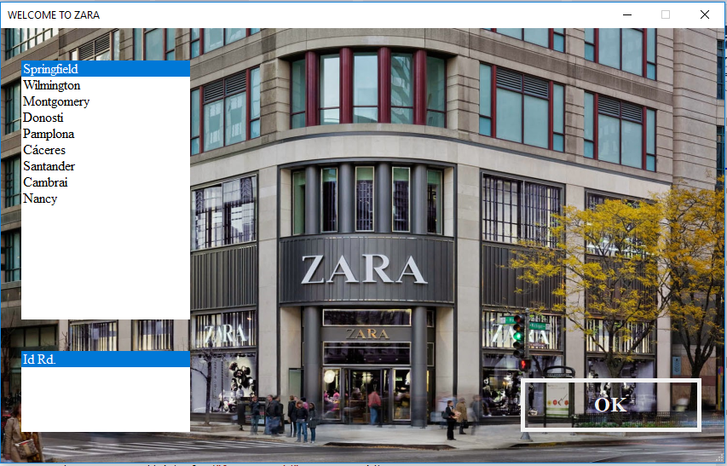

In our demo, the first thing that you have to do is select the store that you are at. In the real world, this process would not be necessary as the employee or the customer would have direct access to the Main form. We need the store location to obtain the store_id. The reason behind this is that each store has different products.

This would be the Main window of the application.

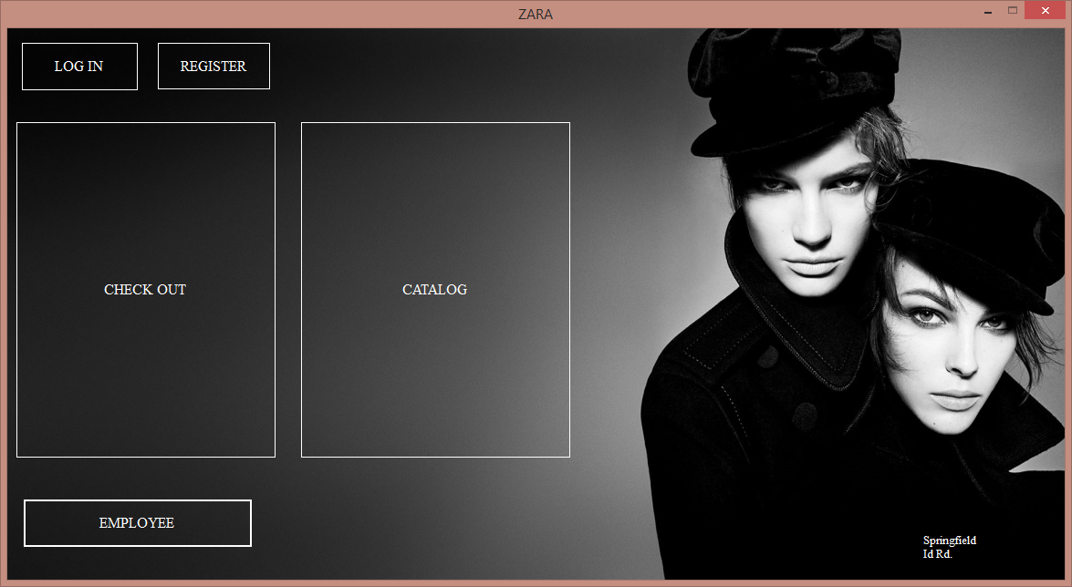

In it you have different options:

* **Catalog:** it lets the customers browse the products that are in store and their price by departments and categories. As shown in the second image, if the product that they want is not in store (since not all products are at all stores) it suggests other store locations where they may find it.

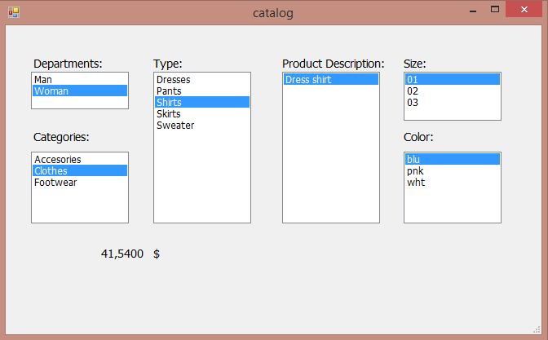

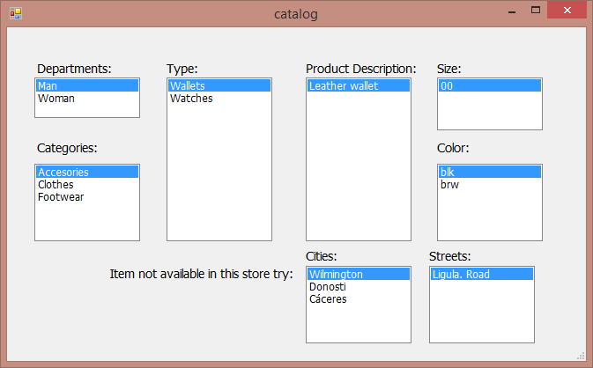

* **Log in:** it lets the customers log into their account. Once they’ve successfully logged in, they have two options. They can either modify their credit card numbers or they can modify their profile.

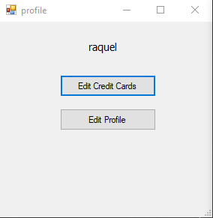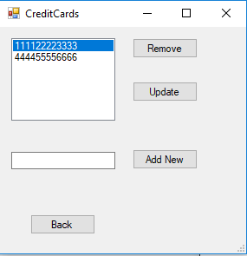

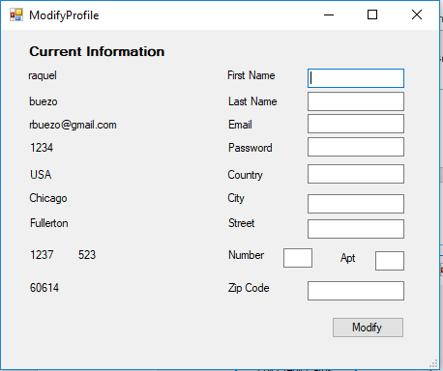

* **Register:** New customers can create an account by filling in the fields.

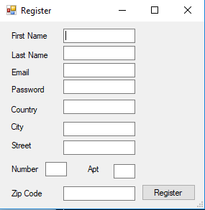

* **Checkout:** Customers introduce the UPC_code and quantity of the different products they are going to buy. The contents of the shopping bag are shown in a list on the bottom left corner and the total is summed up. Then the customer must choose or enter their credit cards and finish checking out.

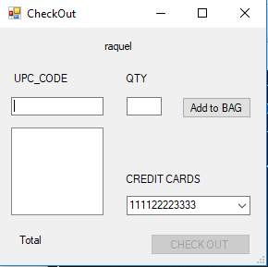

* **Employee:**  In this window, employees can see what products they have in their store as well as update the price and quantity or order more products from the vendor. The constraint of maximum inventory size is used to decide whether an order can be placed or not.

